2014

[Multipurpose Real Property Complex –Algeria Zone 2 OFFICE BUILDINGS]

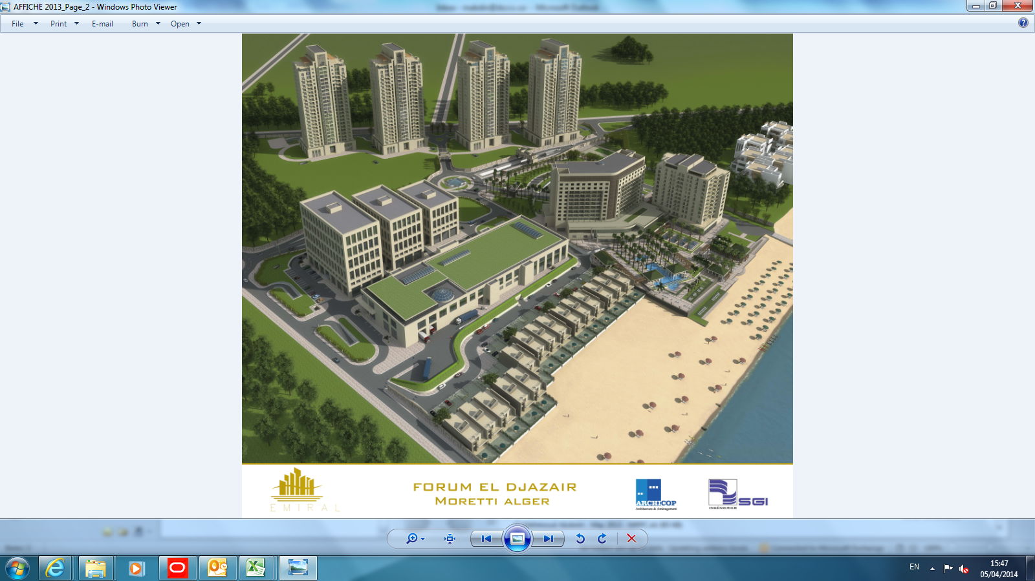

Contents

- Project Brief
- Program Overview
- Key Dates/Milestones
- Work Breakdown Structure
- Calendars
- Activity Codes & ID
- Construction Sequence
- Project Baseline Schedule
- Critical Path
- Qualifications
- Appendices
- Project Baseline
- Critical Path
- CD Attachment
- Histograms

Project Brief

Project is located in the town of Staoueli, Wilaya of Algiers to build a Polyclinic (7 Storey Building) and 2 Office Building (9 & 11 Storey Buildings)

Program Overview

The purpose of this schedule is to show the sequence of execution of the 3 buildings presenting all activities that will be executed to carry out the works.
The new schedule utilizes Primavera P6 Project Management. The total number of activities is 3353 Inclusive all milestones and various stage/activities of Mobilization, Engineering, Procurement, Construction, Testing & Commissioning and Handing over. Program is resource loaded with Manhours, Cash Flow & Material (Concrete, Reinforcement , FW etc……)

Key Dates/Milestones

Developed program with data date 1st of February 2013 shows 31st of March 2016 as the completion date of the project as per contract (26 Months), the below tables shows the main dates of different project levels.

Milestones:
Activity ID | Activity Name | Original Duration | Start | Finish
General Requirement & Milestones |  | 649 | 01-Feb-14 | 31-Mar-16
GEN1010 | Preliminaries | 790 | 01-Feb-14 | 31-Mar-16
GEN1000 | Commencement Date | 0 | 01-Feb-14
GEN1020 | SONELGAS NOC | 0 | 01-Feb-14
GEN1030 | CIVIL PROTECTION NOC | 0 | 01-Feb-14
GEN1040 | SEIAL NOC | 0 | 01-Feb-14
GEN1050 | ALGER TELECOM NOC | 0 | 01-Feb-14
GEN1100 | Finish Date | 0 |  | 31-Mar-16

Key Dates:

Activity ID | Original Duration | Start | Finish
FORUM EL DJAZAIR - Zone 2 - OFFICE BUILDINGS | 649 | 01-Feb-14 | 31-Mar-16
General Requirement & Milestones | 649 | 01-Feb-14 | 31-Mar-16
Engineering | 298 | 01-Feb-14 | 15-Feb-15
Structural | 200 | 01-Feb-14 | 24-Sep-14
Architectural | 204 | 08-Mar-14 | 05-Nov-14
MEP Shop Drawings | 298 | 01-Feb-14 | 15-Feb-15
Procurement | 455 | 01-Feb-14 | 19-Aug-15
Architectural Packages | 286 | 08-Mar-14 | 07-Mar-15
MEP Procurment | 455 | 01-Feb-14 | 19-Aug-15
Construction | 629 | 01-Feb-14 | 08-Mar-16
Offices Buildings | 623 | 01-Feb-14 | 01-Mar-16
Block 1 | 555 | 01-Feb-14 | 14-Dec-15
Block 2 | 535 | 02-Apr-14 | 18-Jan-16
Block 3 | 523 | 31-May-14 | 01-Mar-16
Podium | 476 | 02-Apr-14 | 23-Oct-15
Part 4 | 410 | 02-Apr-14 | 04-Aug-15
Part 5 | 242 | 09-Aug-14 | 23-May-15
Part 6 | 252 | 27-Nov-14 | 22-Sep-15
Part 7 | 188 | 12-Mar-15 | 23-Oct-15
Provisional Sums | 184 | 08-Aug-15 | 08-Mar-16
Project Handing Over | 111 | 24-Nov-15 | 31-Mar-16
Authority Approvals | 110 | 24-Nov-15 | 31-Mar-16
Drainage | 16 | 06-Mar-16 | 23-Mar-16
Water Supply | 59 | 11-Jan-16 | 19-Mar-16
Fire Fighting | 11 | 20-Mar-16 | 31-Mar-16
Electrical | 54 | 24-Nov-15 | 26-Jan-16
Testing and Commissioning | 111 | 24-Nov-15 | 31-Mar-16
Block1 | 55 | 24-Nov-15 | 26-Jan-16
Block2 | 54 | 11-Dec-15 | 12-Feb-16
Block3 | 58 | 25-Jan-16 | 31-Mar-16
As Built Drawing and O&M Manuals | 22 | 02-Mar-16 | 27-Mar-16
Snagging & Desnagging | 20 | 09-Mar-16 | 31-Mar-16

Work Breakdown Structure

The Work Breakdown Structure (WBS) is per definition is decomposition of a project into smaller components with several levels that helps to organize and define the total work scope of the project. Charts below shows the main decomposition of each section of the project.

Project Decomposition

Engineering WBS (Main Decomposition)

Procurement WBS (Main Decomposition)

Construction WBS (Main Decomposition)

Same as part 4
Same as Block 1 except
Block 2: Basement to 9th Floor
Block 3: Basement 2 to 11th Floor

Project Handing over WBS (Main Decomposition)

Calendars

The standard calendar used in the baseline program comprised of the following; weekends (Friday only) 8 hours working day EXCEPT FOR Ramadan 4 Hours due to lack of productivity. Public and religious holidays have been implemented to the calendar.

Day | Description
Eid El Fitr | 2 Calendar Days
Eid Al Adha | 2 Calendar Days
Independence Day | 5th July
Revolution Anniversary | 1st November
El Mawlid Annabawi | 12th Rabie Al Awal (Changeable)
Awal Mouharam | 1st Mouharam (Changeable)
Achoura | 10th Mouharam (Changeable)
Labour Day | 1st May

Activity Codes & ID

Activity codes & ID are assigned to the activities to help in monitor and control of the project they are as follows:

Activity ID
All activities has been assigned a code in a simple way to help in finding any activity, methodology implemented is shown in the following activity as an example where activity ID is highlighted in yellow:
BL1-FN-B2-1000: Block Works
Activity Name | Activity Code | Description
Block Work | BL1 | Block 1
 | FN | Finishing
 | B2 | Basement 2
 | 1000 | Number assigned by software

General Codes
No. | Activity Code
1 | ENGINEERING
2 | PROCUREMENT
3 | Structural
4 | Finishing
7 | Responsibility

Activity Code No.1: ENGINEERING

Code Value | Description
Str | Structural Drawings
Fin | Architectural Drawings
MEP | MEP Drawings

Activity Code No.2:Procurement

Code Value | Description
Fin | Finishing Packages
MEP | MEP Packages

Activity Code No.3:Structural

Code Value | Description
Str | Structural Activities

Activity Code No.4:Finishing

Code Value | Description
Fin | Finishing Activities

Activity Code No.5:Responsibility

Code Value | Description
MEP | MEP Activities

Construction Sequence

Structural Sequence

Structural sequence which will drive other disciplines (Finishing & MEP) and drive the whole project was implemented on the program after excessive amount of discussions with construction team, project manager and control team so that sequence of works is built up according to what will be constructed on site so close monitoring would be applicable.
Sequence of work is as follows:

Project Baseline

Refer to Full schedule attached in appendices the attached schedule shows 7 columns which are:
- Activity ID
- Activity Name
- Original Duration
- Start Date
- Finish Date
- Total Float

Any other column can be viewed on Primavera program itself (XER file is attached with the baseline submission CD Attachment).

Critical Path

The critical path is represented by the following diagram.

Detailed critical activities are shown in Appendices.

Qualifications:

MEP / Handing Over Qualifications:
- NOC’s to be delivered on the 1st of February 2014.
- Power Single Line diagram for the Offices are missing from the received IFC drawing to be issued by SGI/EMIRAL.
- Fire alarm schematic & design to be issued by Emiral.
- Fire Fighting & Desmoke design to be issued by SSI/ Emiral.

Appendices

- Project Baseline.
- Critical Path.
- CD Attachment.
- Histograms.

Appendix A (Project Baseline)

Appendix B (Critical Path)

Appendix C (CD Attachment)

Appendix D (Histograms)

